12.25

HK closed today and tmrw. US will be closed as well.

Personal view:

Markets expected to be quiet this time of year. Don’t move much.

10:21

Strength regresses to ytd sharpe.

Big caps > HS300 > main > Shenzhen > zhongzheng > cyb.

12.26

Keep jan position light.

Stock accumulation wait until mid Jan.

Secondary trading of convertibles. Especially those below market values.

Good pmcl trading today. On both ETF and futures made money.

Fut: lighten during tomorrow’s confusion.

Stock: hold.

12.27.2017

Markets crash. Didn’t sell enough in confusion period.

Liquidity tight, GC001 goes to 12%.

Jan faces some risk offloading/end of year distribution etc.

Keep positioning light until feb.

14:45

Markets crash fully

Moutai’s turnover is less now at 0.27% for this drop, most of the short traders washed out. Prepare to build some pos here.

A50 ETF:

Build pos

Building speed:

5% of ptf per day. Up to 10% for crashes. (100k~ 200k delta)

Back Fut:

Trading at a huge premium. 13050/13088 (40-50 bps premium)

Don’t want to roll here (paying too much to roll)

Next pm is tradable by futs. Stocks move up slowly 100k. (some moutai + some ETF)

January has historically low sharpe. Make sure to stay low on the deltas.

Tonight:

Keep picking up jan delta.

Tmrw morning, liquidate some position.

Tmrw afternoon, add some pos.

Today we are picking up some Jan delta.

After a mini crash it is a good spot to start buying some stuff.

But note January net delta cannot exceed half the total pos at any time.

12.28.2017

Played PD last night. Accumulated with little position.

Opened up and had a upward rally.

Overnight risk is compensated wel.

Having wtd PD would be nice. Ytd PD dropped to 0 and picked premium up 0, now it is at 0.5%.

Accumulated @ flat premium.

Now it is back to ytd’s normal premium.

Trend pnl snaps back to positive. Ytd’s wash was healthy.

1. Take overnight risk (charge overnight holding fee for day traders), when deeply in discount
2. Sell hopes of rebound to market before open
3. Avoid too much risk overnight, don’t want news.
4. Make sure of full PD advantage at entrance. Ytd entered at a 50 bps advantage.
5. Always be wary of trend pnl continuation.

The roll ytd was done at a good level.

12.29.2017

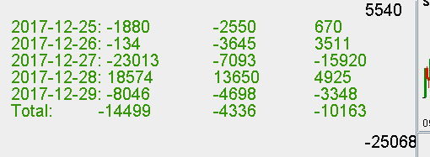

Weak week. Wed’s crash got compensated (non fully).

Moutai did well.

-15k on Changjiang elec.

12.30

This week’s true advantage is discount resetting back to normal.

Rates have been insanely high at 17% as cash shortage lingers.

To make money in these markets you need correct positioning.